Tiwari right wrist movement:

(up and relax)

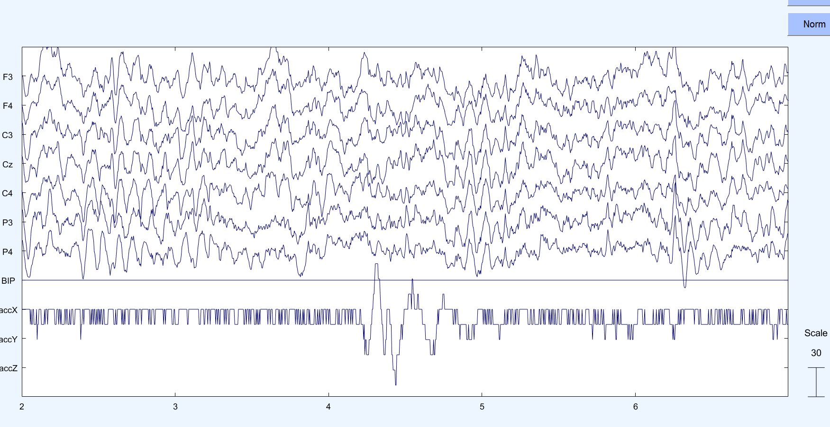

Figure channel_data (scroll): observe from 4s to 5s disturbance in accX: that is wrist movement

# FFTs:

### Relaxed wrist:

Obsn 1:

Obsn 2:

Obsn 3:

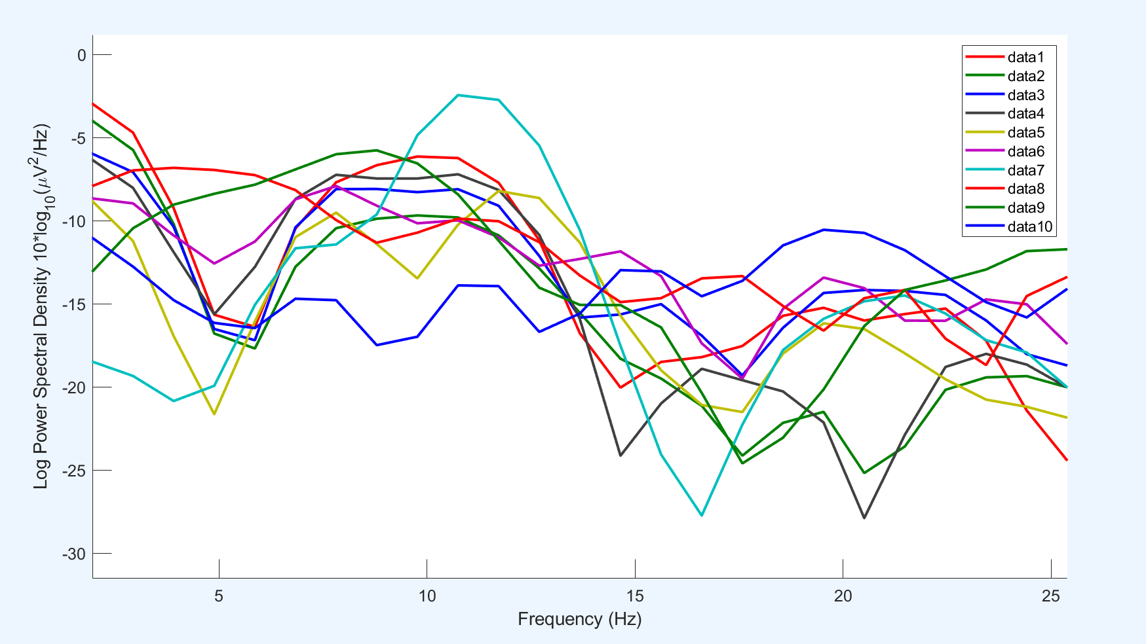

Obsn 4:

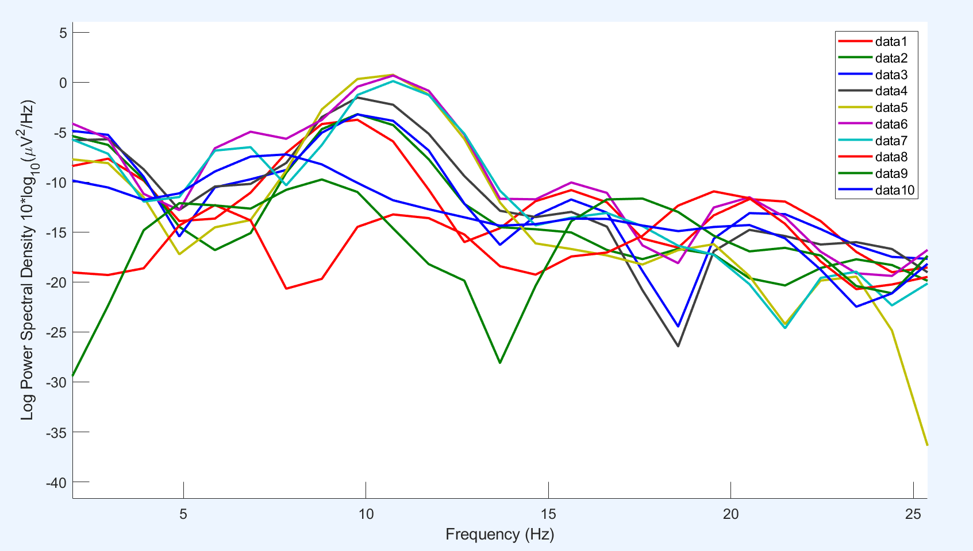

Obsn 5:

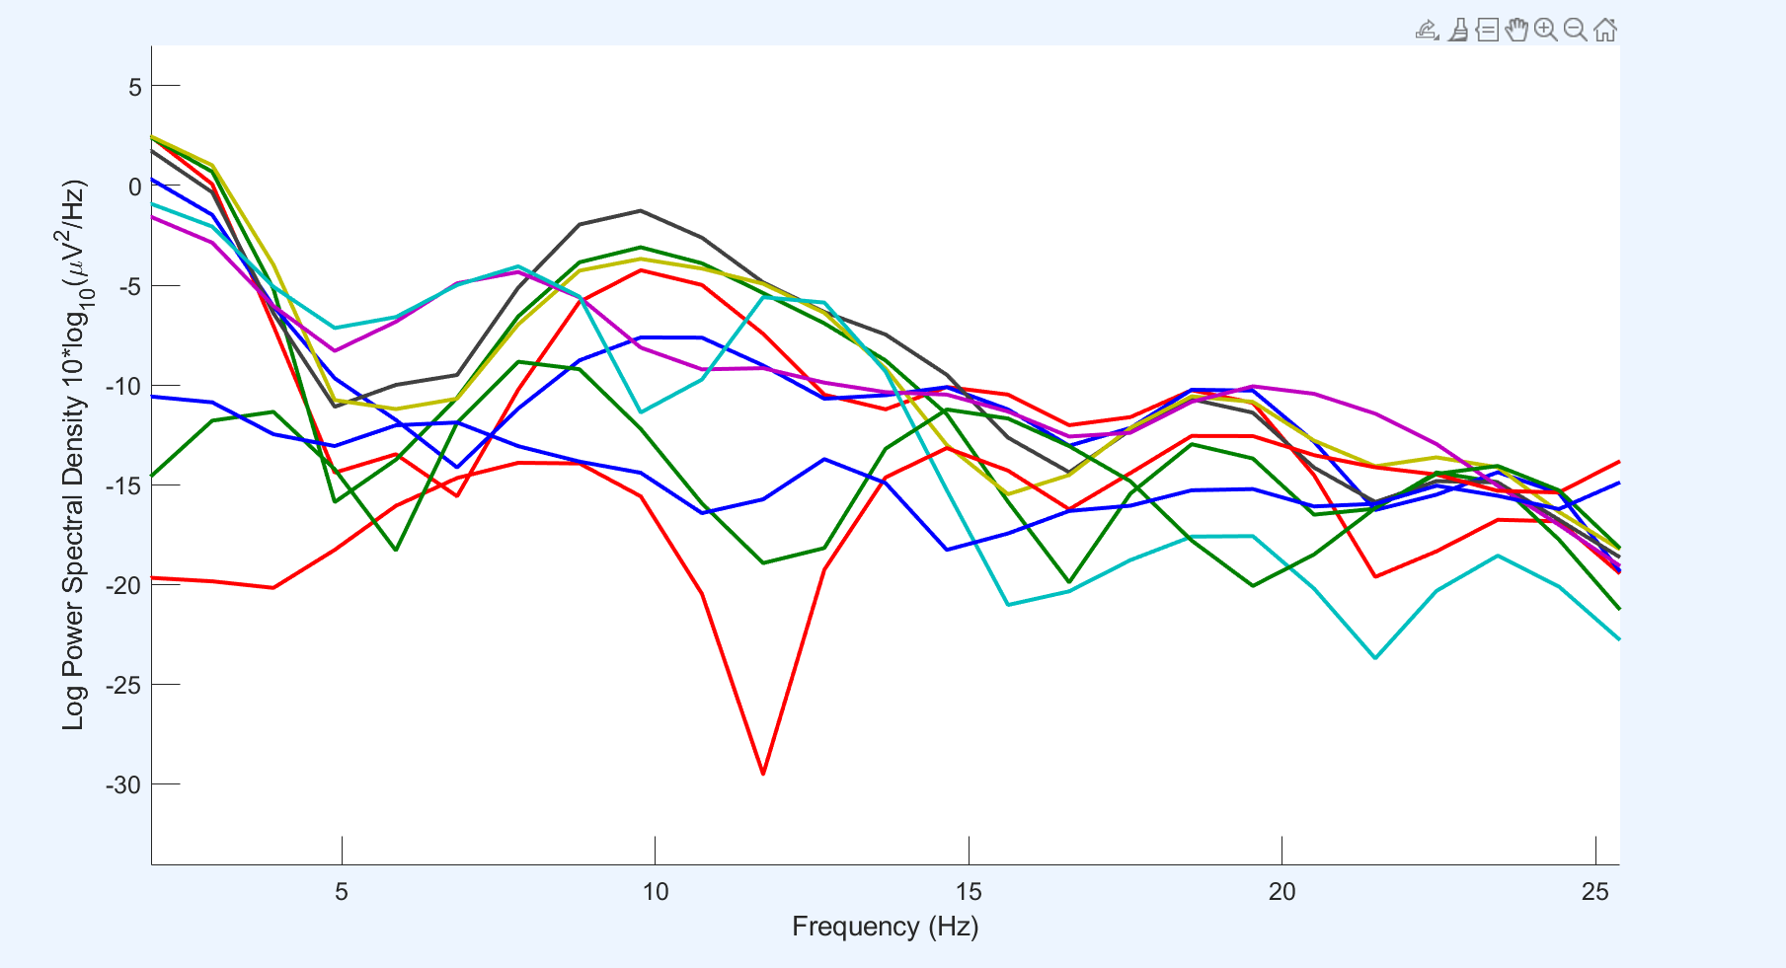

### When active:

Obsn 1:

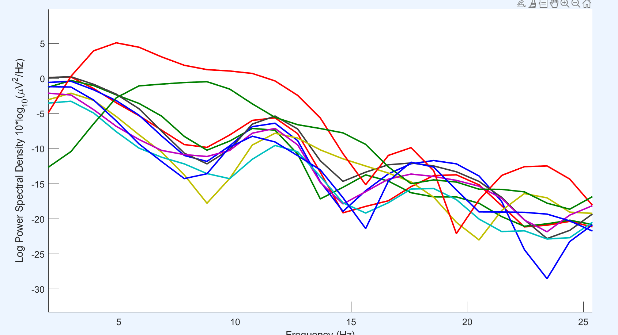

Obsn 2:

Obsn 3:

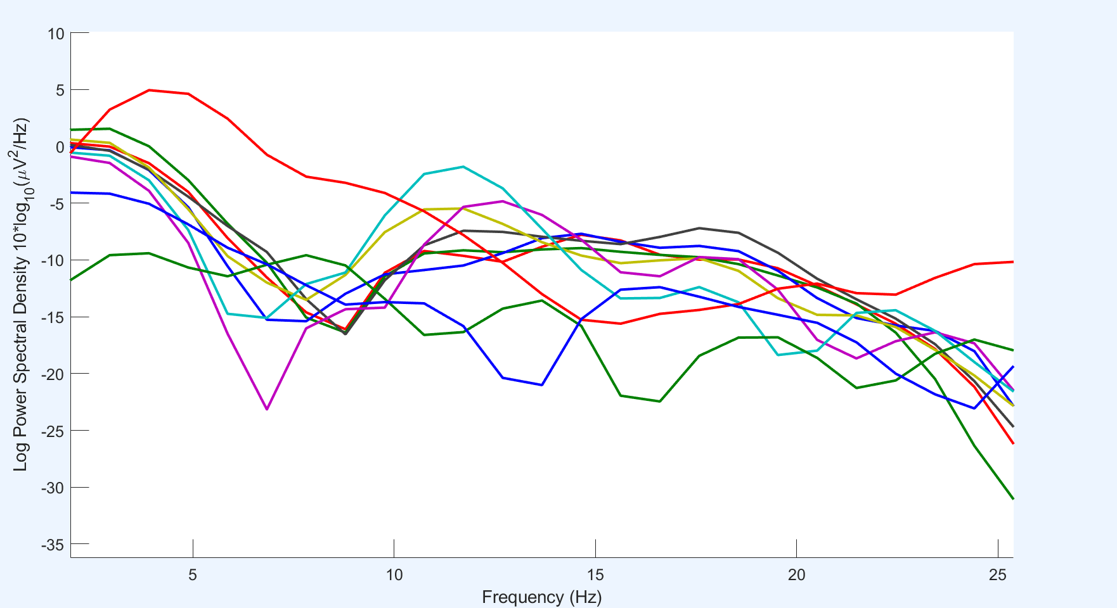

Obsn 4:

Obsn 5:

